**Tutorial 1: Agile and Testing**

**A. Discussion**

1. What is your understanding of agile methodology?

2. In software testing, what are some of the tests that you will be doing?

**B. Identifying Defects**

A software defect is a condition in which the software does not meet certain requirements stated in the requirement specifications. It can be a coding or logic error that causes a program to produce wrong or unexpected results.

It is important to be able to identify defects.

In this exercise, you will need to identify defects on websites.

**Question 1:**

Find more than 20 defects (layout inconsistencies, spelling errors, and the like) in the image below:

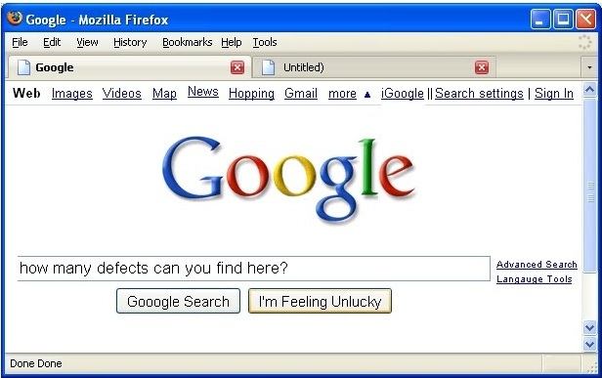

**Question 2:**

How many defects can you see on the page shown below?

[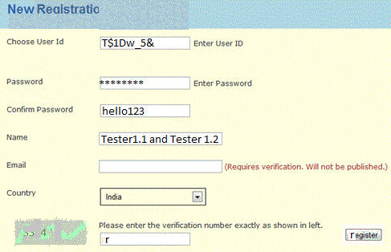](https://cdn.softwaretestinghelp.com/wp-content/qa/uploads/2014/08/testing-Exercise-1.jpg)

**C. Software Testing**

Software testing (validation) is part of the software processes to check if the actual results will match the expected results. It helps to spot errors or missing requirements or misunderstood requirements. Software testing can be done manually or automated tools.

There are many types of testing such as functional testing (unit testing, integration testing, UAT, etc), non-functional testing (performance, usability, etc) and maintenance testing.

In this exercise, we will learn about identifying tests for some of the programs.

You should include an input, action/event and an expected response, in order to determine if a feature of an application is working correctly.

We are basically writing a set of instructions on “HOW” to validate a particular test objective/target, which when followed will tell us if the expected behaviour of the system is satisfied or not.

**Question 1**

This is a simple program with the following items:

* Input Box A
* Input Box B
* ADD button
* Result Text Box [=A+B]

What results are you expecting?

What can go wrong?

Identify all the different types of tests you can think of for the above program.

**Question 2**

The code for the program below will allow the user to enter the height, width and depth of a water tank, then calculate and output the capacity.

**Interface**

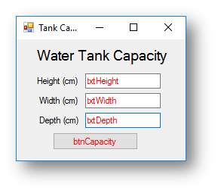

**Code when btnCapacity is clicked**

'three variables that store the text box inputs from the interface as a decimal

Dim height As Decimal = txtHeight.Text

Dim width As Decimal = txtWidth.Text

Dim depth As Decimal = txtDepth.Text

'calculation to work out the capacity

Dim capacity As Decimal = (height * width * depth) / 1000

'outputs the capacity of the water tank

MessageBox.Show("The tank holds " & Decimal.Round(capacity, 2).ToString & " litres of water")

What results are you expecting?

What can go wrong?

Identify all the different types of tests you can think of for the above program.

**Question 3**

The code for the program below will ask the user to enter a score on a test and then decide what grade they got.

**Interface**

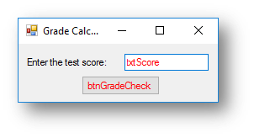

**Code when btnGradeCheck is clicked**

Dim score As Integer = txtScore.Text

If score >= 70 Then

MessageBox.Show("That test score is an A grade")

ElseIf score >= 60 Then

MessageBox.Show("That test score is a B grade")

ElseIf score >= 50 Then

MessageBox.Show("That test score is a C grade")

ElseIf score >= 40 Then

MessageBox.Show("That test score is a D grade")

Else

MessageBox.Show("That test score is a U grade")

End If

What results are you expecting?

What can go wrong?

Identify all the different types of tests you can think of for the above program.